**COIMBATORE INSTITUTE OF TECHNOLOGY, COIMBATORE – 641 014**

**(Government Aided Autonomous Institution affiliated to Anna University)**

**COIMBATORE-641014**

**DEPARTMENT OF ELECTRONICS AND COMMUNICATION ENGINEERING**

**B.E, VI SEMESTER**

**ADA LOVELACE DAY HACKATHON**



**AI BASED POETRY GENERATION(SONNET)**

**SUBMITTED BY:**

**K.J.BHASKER A.RAGAVENTHRAN**

**(**[**1804012ece@cit.edu.in**](mailto:1804012ece@cit.edu.in)**)** [**(1904205ece@cit.edu.in**](mailto:1904205ece@cit.edu.in)**)**

**N.SUBHIKSHA R.SIVASANDHIYA**

**(**[**1804055ece@cit.edu.in**](mailto:1804055ece@cit.edu.in)**) (**[**1804053ece@cit.edu.in**](mailto:1804053ece@cit.edu.in)**)**

**Department of Electronics and Communication Engineering**

**PROBLEM STATEMENT:**

To build and train an AI model with the given dataset to generate a poem(sonet).

**CONTENTS:**

* **SOLUTION CONCEPT**
* **SETUP**
* **DOWNLOADING WEIGHTS FOR OBJECT DETECTION**
* **READING AND ALIGNING THE DATASET**
* **PROCESSING THE DATA**
* **PREDICTION PROCESS**
* **CREATE TRAINING AND TARGETS**
* **ALLOCATING BATCHES**
* **MODEL**

1. **TRAIN THE MODEL**
2. **EXECUTE THE TRAINING**
3. **GENERATING POEM**

* **CONTEXT FROM THE PICTURE**
* **CONCLUSION**

**SOLUTION CONCEPT:**

We build this model with RNN concept ,to predict the words for the given starting string and generate a poem(14 lines) with approximate sentence meanings.

While some of the sentences are grammatical, most do not make sense. The model has not learned the meaning of words, but consider:

* The model is character-based. When training started, the model did not know how to spell an English word, or that words were even a unit of text.
* The output resembles a play—blocks of text with any input string.

**SETUP:**

Install and import the following library file for this model

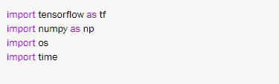

**DOWNLOADING WEIGHTS FOR OBJECT DETECTION:**

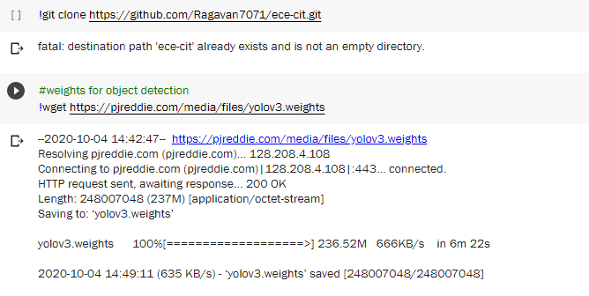

In the first cell we just cloned the github repository to get necessary configurations and datasets.and in the second cell is for downloading weights for reading the context from the input image,it will take around 237 mb.

We used ‘yolov3’ weights which is the standard object detection weights dataset for standard configuration ,it consist of around 80 trained objects you can refer the objects from ‘coco.names’ on ‘names folder’ in the github repository

**READING AND ALIGNING THE DATASET:**

I used ‘text.txt’ my input dataset which will available in my github repository,the file path is given from the cloned github repository



Go Through the dataset should be aligned properly before feeding into the training process to avoid logical errors in the output.



**PROCESSING THE DATA:**

Check the unique characters in the dataset and vectorize the text.Before training, we need to map strings to a numerical representation. Create two lookup tables: one mapping characters to numbers, and another for numbers to characters.



Now we have an integer representation for each character.

**PREDICTION PROCESS:**

Given a character, or a sequence of characters, what is the most probable next character? This is the task we're training the model to perform. The input to the model will be a sequence of characters, and we train the model to predict the output,the following character at each time step.Since RNNs maintain an internal state that depends on the previously seen elements, given all the characters computed until this moment, what is the next character?

### **CREATE TRAINING AND TARGETS:**

Next divide the text into example sequences. Each input sequence will contain “seq_length” characters from the text.For each input sequence, the corresponding targets contain the same length of text, except shifted one character to the right.So break the text into chunks of “seq_length+1”. For example, say “seq_length” is 4 and our text is "Hello". The input sequence would be "Hell", and the target sequence "ello".To do this first use the “tf.Data.dataset.from_tensor_slices ”function to convert the text vector into a stream of character indices.



**ALLOCATING BATCHES:**

The batch method lets us easily convert these individual characters to sequences of the desired size.



For each sequence, duplicate and shift it to form the input and target text by using the map method to apply a simple function to each batch

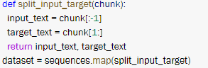

Each index of these vectors are processed as one time step. For the input at time step 0, the model receives the index for "F" and tries to predict the index for "i" as the next character. At the next timestep, it does the same thing but the RNN considers the previous step context in addition to the current input character.to check that in the program we make print that indexes.

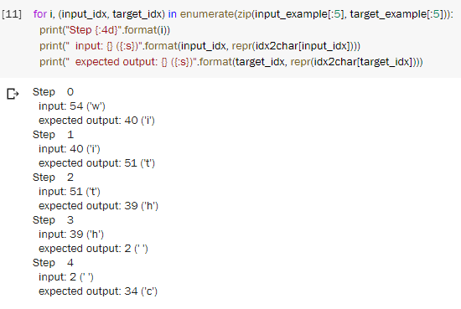

We used tf.data to split the text into manageable sequences. But before feeding this data into the model, we need to shuffle the data and pack it into batches.

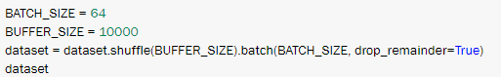

**MODEL:**

Use tf.keras.sequential to define the model. For this simple example three layers are used to define our model:

* tf.keras.embedding: The input layer. A trainable lookup table that will map the numbers of each character to a vector with embedding_dim dimensions;
* tf.keras.GRU: A type of RNN with size units=(You can also use a LSTM layer here.)
* tf.keras.layers.dense: The output layer, with vacob_size outputs
* For each character the model looks up the embedding, runs the GRU one timestep with the embedding as input, and applies the dense layer to generate logits predicting the log-likelihood of the next character:

Now run the model to see that it behaves as expected;



Also look on to the model summary :

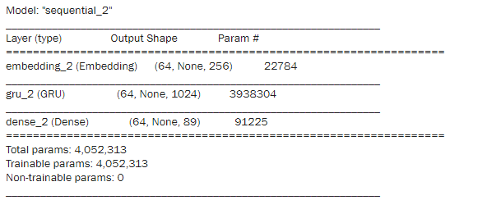

Try it for the first example in the batch,it will give the prediction text as array,



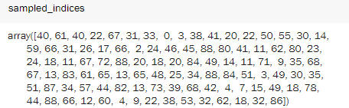

**TRAIN THE MODEL:**

To decode the array to get predictive text output



At this point the problem can be treated as a standard classification problem. Given the previous RNN state, and the input this time step, predict the class of the next character.Attach an optimizer, and a loss function

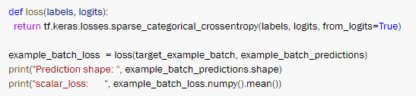

Configure the training procedure using the tf.keras.Model.compile method. We'll use tf.keras.optimizers.Adam with default arguments and the loss function.



Use a tf.keras.callbacks.ModelCheckpoint to ensure that checkpoints are saved during training:

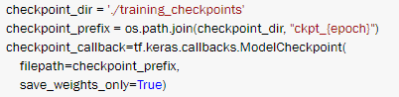

**EXECUTE THE TRAINING:**

Here I used 3 epochs for my training to get a good trained model ,according to your GPU and dataset you can modify it.

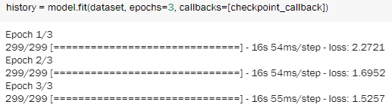

**GENERATING POEM:**

To run the model with a different batch_size, we need to rebuild the model and restore the weights from the checkpoint.Restore the latest checkpoint,and take the model summary once again,because now the model is trained

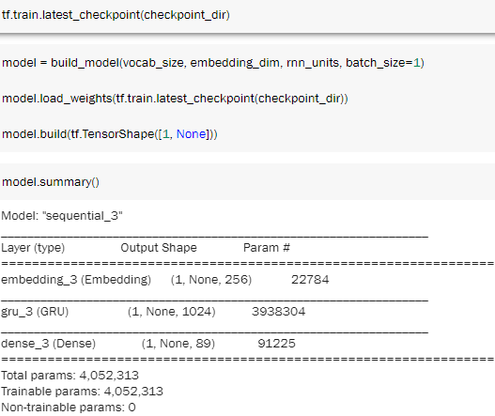

You can also experiment with a different start string, or try adding another RNN layer to improve the model's accuracy, or adjusting the temperature parameter to generate more or less random predictions.now call the function to generate a poem,

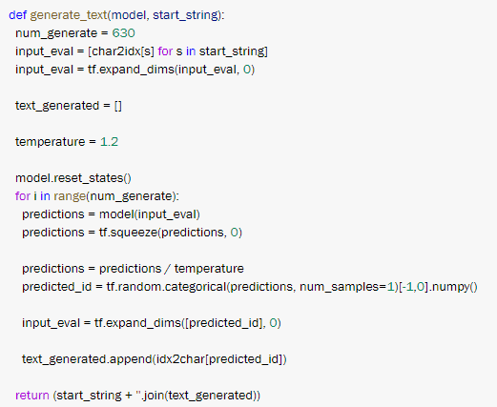

Now the function are defined and the model is trained write a snippet to get the starting string as the input from the compiler and print the generated poem

**CONTEXT FROM THE PICTURE:**

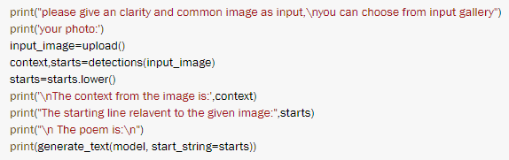

This snippet helps to get an image as input and read the context in it,and from that context the relevant starting string is generated to give a poem as output

The starting strings can be referred from ‘st.names’ in names folder on my github repository

As the weights of image detections are limited,you can download the input images from ‘gallery folder’ .

The output of the model is:

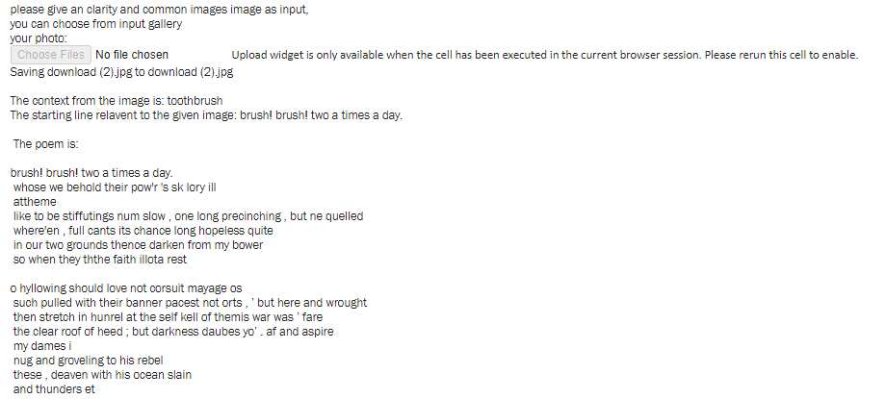

**CONCLUSION:**

Thus the poem is generated using the model which is trained by the given dataset ,you can increase the efficiency of the model by increasing the training dataset,or increasing the epoch value.